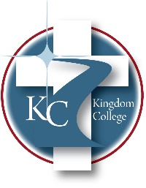
KC 100.13
Administrative Meetings
Last Revision/Approval Date: 2/7/2024
______________________________________________
Purpose:
This group consists of the administrators of Kingdom College. This group meets together to have an avenue of planned meetings and documented action items to ensure compliance with all accreditation requirements/guidelines and institutional requirements. Primary members will be the President, Chief Academic Officer, Director of Enrollment and Student Services, Chief Financial Officer, and Director of Human Resources. Other staff members may participate in these meetings as needed or as their availability allows. Meetings will be held regularly; if needs arise outside the scheduled meeting times, called meetings can be held.

The Administrative Assistant will keep documentation as to the current action items and projects.

