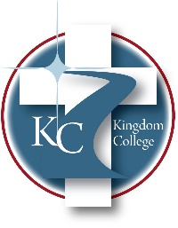
KC 100.4
Mission/Vision Statements
Last Revision/Approval Date: 04/23/2025
______________________________________________

OUR MISSION
Kingdom College is a Christian college dedicated to preparing and equipping God’s people for works of service (Ephesians 4:11-12 NIV) by teaching students on the undergraduate and graduate levels to perform works of service in the areas of Biblical Studies, Psychology, Counseling, and Career & Community Development.

OUR VISION
A Christian college sending forth His people empowered by The Holy Spirit through love to fulfill His divine plan as seen in Acts 1:8, “But you will receive power when The Holy Spirit comes on you; and you will be my witnesses in Jerusalem, and all Judea and Samaria, and to the ends of the earth,” and Matthew 28:19, “Therefore go and make disciples of all nations, baptizing them in the Name of The Father, and of The Son and of The Holy Spirit” in the fields of Biblical Studies, Psychology, Counseling, and Career & Community Development to establish strength, hope, and soundness to the people in the global and local marketplace.

