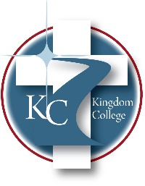
KC 100.9
Board of Directors Purpose
Last Revision/Approval Date: 2/7/2024
______________________________________________
The Board of Directors’ purpose is to oversee, guide, and direct the operations of Kingdom College in accordance with the requirements of the institution’s By-laws and Board Governance Manuel. The Board of Directors is the fiduciary custodian of the institution’s finances and the caretakers that ensure the Mission and Vision of Kingdom College align with the institution’s By-Laws and the expectations of the populations served by this institution.

