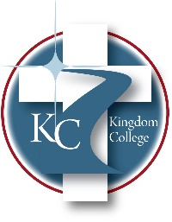
KC 200.24

Curriculum Policy Guidelines

Last Revision/Approval Date: 03/02/2023

Curriculum standards at Kingdom College are held to the highest level of scrutiny, accountability, and professionalism. Kingdom College curriculum standards adhere to state and federal regulations, guidelines, and professional standards from accreditation bodies such as SACS, TRACS, and College and Career Ready Standards. Specific programmatic standards within Kingdom College are aligned with specific industry and academic standards within the specific field of study. Kingdom College seeks to adhere to all pertinent state and federal laws and accrediting body policies while remaining true to the mission and vision of Kingdom College.

Kingdom College instructors who are qualified subject matter experts in their content field develop their respective courses and curricula. The Chief Academic Officer overseeing course content and curriculum development reviews and approves their proposed courses and curricula. Courses and curricula are regularly reviewed and evaluated based on the abovementioned guidelines.
*Curriculum Policy developed 7-8-19

