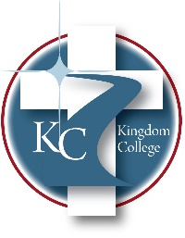
KC 200.26
COMPLAINT POLICY FOR STUDENTS RECEIVING VA EDUCATION BENEFITS
Last Revision/Approval Date: 03/02/2023

Complaint Policy for Students Receiving VA Education Benefits
For students receiving VA education benefits, any complaint against the school should be
routed through the VA GI Bill® Feedback System by going to the following link:
http://www.benefits.va.gov/GIBILL/Feedback.asp. The VA will then follow up through the
appropriate channels to investigate and resolve the complaint satisfactorily.
GI Bill® is the U.S. Department of Veterans Affairs (VA) registered trademark. More information about education benefits offered by VA is available at the official U.S. government Web site at https://www.benefits.va.gov/gibill.

STUDENTS’​ RIGHTS​​ IN​​ THE COMPLAINT PROCESS​
- Right ​to ​​be ​​informed ​​of​​ the ​​​process​
- Right ​to ​​a ​​meeting ​​to​​ plead​​ the​​ student’s​​ case​
- Right ​to ​​be ​​informed ​​of​​ all​​ evidentiary ​​material​​ gathered ​​that​​ ties ​​the​​ student ​​to ​​the​ complaint or values​ violation
- Right ​of ​​the​​ student ​​to​​ give testimony, ​​to​​ decline ​​to​​ testify,​​ and ​​to​​ request​​ personal​ witnesses ​be ​​present ​​at​​ the​​ meeting ​​to ​​testify​
- Right ​to ​​bring ​​a​​ personal​​ witness​​ such​​ as​​ a​​ counselor, ​​advisor, ​​or ​​friend to the​ meeting

