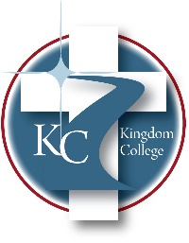
KC 200.28
Policy for Protecting the Privacy of Students Enrolled in Online Courses
Last Revision/Approval Date: 10/30/2025
______________________________________________

Kingdom College offers hybrid and online delivery methods as part of our Distance Education opportunities. DreamClass is our cloud-based School Management System that includes our Learning Management System and Student Information System. All information and performance data are stored in one place. The system streamlines student admissions and enrollment, academic progress monitoring, attendance tracking, grade management, timetable scheduling, and communication. Additionally, it provides reports and analytics for data-driven decision-making.

Features of DreamClass include:
- Admission management that digitizes, automates, and upgrades all aspects of the admission process cycle.
- Class management creates an online representation of classes.
- Student management creates student profiles and manages student-related processes.
- Attendance management tracks and shares attendance data.
- Teacher management gathers teachers’ data in one place.
- Academic management, such as assessment creation and gradebooks.

All transactions are processed through a gateway provider and are not stored or processed on our servers. The program incorporates the highest standards to ensure student privacy.

