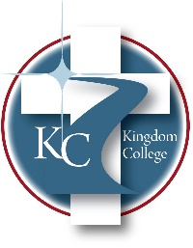
KC 200.4
Dual Enrollment:
Last Revision 2/8/2024
______________________________________________

Kingdom College allows cooperating high schools to allow students to receive both high school and college credit for certain courses that apply toward their coursework required for graduation. Each of these students must be in either grade 10, 11, or 12. The student must obtain a recommendation from the high school guidance counselor or principal. In addition, the student’s grade point average must be at least 2.5 unless the County or School System that the student is coming from states otherwise. Students must also meet all other admission criteria to begin classes with the exception of high school graduation. The tuition for the Dual Enrollment Program is free; the student is responsible for application fees and his/her books.

