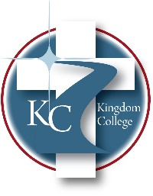
KC 200.6
Program Lengths
Last Revision/Approval Date:10/28/2025
______________________________________________
Each degree program has a specific number of credit hours required:
Certificate Programs offered
- Biblical Studies Certification – 12 hours
- Chaplaincy Certification – 12-15 hours
- Advanced Chaplaincy Certification – 24-27 hours
- Crisis and Trauma Certification – 12 hours
- Bereavement and Grief Counseling Certification -12 hours
- Lay Counseling Certification– 12 hours
- Introduction to Law Enforcement Certification – 12 hours
- First Responder Chaplaincy Certification – 12 hours
Associate degree programs offered
- Associate of Science in General Studies – 60 hours
- Associate of Science in Biblical Studies – 72 hours
- Associate of Science in Psychology – 66 hours
Baccalaureate degree programs offered
- Bachelor of Arts in Biblical Studies – 120 hours
- Bachelor of Science in Addictions Counseling – 120 hours
- Bachelor of Science in Counseling Psychology – 120 hours
- Bachelor of Science in Psychology – 120 hours
Master’s degree programs offered
- Master of Arts in Biblical Studies - 45 hours
- Master of Divinity – 90 hours
- Master of Science in Clinical Psychology – 48 hours
- Master of Science in Christian Clinical Mental Health Counseling – 60 hours

