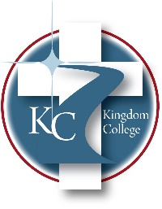
KC 200.7
Tuition Costs & Fees
Last Revision/Approval Date: 11/17/2025
______________________________________________
Kingdom College aims to offer an education to everyone who qualifies for admission, regardless of his or her financial readiness for college. For this reason, Kingdom College has sought to create affordability for its students. Kingdom College is primarily tuition-funded. All expenses for each semester are due at the beginning of the semester. Any expenses not paid by the start of the semester could be assessed as a late charge, which will be added to the amount due to Kingdom College unless a student requests a change and is approved for a payment plan. The Chief Financial Officer will help students who request to establish a payment plan. Any student with an outstanding balance at the end of a semester will be denied the opportunity to receive his/her grades, receive a transcript, or register for a future semester unless arrangements are made with the Finance Office. Below is the breakdown of expenses per semester for students at Kingdom College.
Tuition: $175 per credit hour (Certification)
$275 per credit hour (Undergraduate)
$375 per credit hour (Master’s)
Fees: $350 Semester Fees (includes: Registration, Facilities, Technology, and General)

*For most current tuition & fees for Dual Enrollment courses, contact the Kingdom College Administrative Office.

