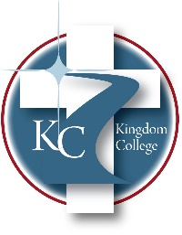
KC 200.9
Student Rights
Last Revision/Approval Date: 12/16/21

ACADEMIC RIGHTS
It is the right and responsibility of each student to know and be fully aware of the policies and procedures at Kingdom College. These policies and procedures are expressed in the Student Life Handbook. The Student's Rights are as follows:
- The right to be respected by faculty, staff, and classmates.
- The right to have access to his/her professor or staff member if he/she has a question
about the academic process in the class or within Kingdom College.
- The right to know the expectations of each course in which he/she participates.
- The right to know how grades are ascertained in any course.
- The right to appeal a grade.
- The right to be advised in an appropriate manner and in a timely manner of the path of
his/her program courses.

