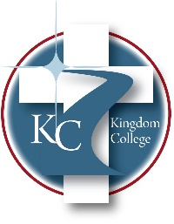
KC 300.18

Pay Plan
Last Revision/Approval Date: 03/02/2023
______________________________________________
The salaries of Kingdom College employees are regulated by established pay ranges approved by the Board. Kingdom College’s official workweek starts Sunday at 12:01 a.m. and ends the following Saturday at 12:00 midnight. A workday is any consecutive 24-hour period. The College’s workday begins at 12:01 a.m. and ends at 12:00 midnight. Nonexempt Employees: Due to the workload at peak times, a “nonexempt” employee’s supervisor may assign him or her to work beyond the normal shift. Kingdom College will pay overtime for overtime work in accordance with the requirements of state and federal law. Although an attempt will be made to give advance notice when it is feasible to do so, this is not always possible. This follows government requirements. As defined by the state labor laws and the federal Fair Labor Standards Act, nonexempt employees will have overtime paid at time and a half for more than 40 hours worked in one workweek. Nonexempt employees who are on an approved alternative workweek will be paid overtime, where applicable, in accordance with their alternative workweek schedule. Overtime is based only on actual hours worked as required.

