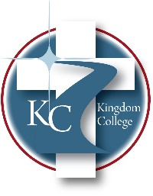
KC 300.21
Employee Assistance Program
Last Revision/Approval Date: 03/02/2023
______________________________________________
The Employee Assistance Program (EAP) is available through Living Waters Counseling to every employee and family member living in his or her household. The program provides a variety of services, including confidential help for those experiencing problems related to life changes and personal stress, emotional and mental health concerns, family conflicts, relationships and marriage difficulties, workplace conflicts, substance abuse/addiction, etc... The service is free, voluntary, and strictly confidential. Please call the Human Resources Department for further information.

