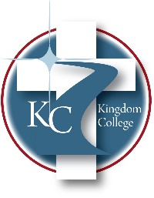
KC 300.22
Employee Conflict of Interest
Last Revision/Approval Date: 03/02/2023
______________________________________________
Employees of the Kingdom College should be aware of a conflict of interest and potential ethics violations regarding using their jobs for personal gain. Employees should not be using an exempt status of Kingdom College to purchase items for their personal use. Any employee found to be breaking this regulation may face Kingdom College disciplinary action. Supervisors are responsible for reporting these violations to the President as soon as the incident is discovered for immediate action.

