
KC 300.27
Health/Safety/Emergency Policy
Last Revision/Approval Date: 5/23/2023

Purpose: Safety is everyone’s responsibility. All members of the Kingdom College community are expected to be familiar with and aware of their safety responsibilities, strive to follow safety practices, act proactively to prevent accidents and injuries, communicate hazards to those in supervision or administration, and be prepared for emergencies in the workplace. Kingdom College is committed to providing a safe environment for faculty, staff, students, and visitors. This policy outlines safety responsibilities to ensure compliance with relevant environmental health and safety laws, regulations, policies, and guidelines.

Contents: The program implemented with this policy includes the following:
- Safety inspections to find and eliminate unsafe working conditions or practices, to control health hazards, and to comply with applicable local, state, and federal codes including those required by the Occupational Safety and Health Administration (OSHA)
- Training personnel in any job-specific hazards and how to avoid them
- Providing necessary personal protective equipment (PPE) to enhance the safety of the workplace
- Developing and enforcing safety and health rules, requiring that all affected personnel cooperate with these rules as a condition of employment
- Investigating promptly and thoroughly occupational accidents to determine the cause and how to prevent a reoccurrence
- Locating and educating members on evacuation plans in the event of an emergency

Responsibilities: All members of the Kingdom College community are responsible for ensuring good safety and health procedures are always followed. Below are specific responsibilities outlined for roles within the college.

Supervisors and Faculty:
- Require all staff members under their direction to attend required safety training
- Maintain workplaces and equipment under their control in safe, well-kept condition
- Identify hazards and make efforts to correct them immediately
- Dispose of waste properly and in accordance with college, state, and federal requirements

Students:
- Comply with this policy and all other college health and safety programs
- Inform an instructor or staff member of any safety or health hazards on college property or at instructional sites
- Know your role in the event of an emergency

Employees and Staff:
- Observe all safety and health rules and procedures
- Report unsafe conditions and practices to the supervisor as soon as possible
- Conduct work activities in a manner that will not endanger others
- Makes safety suggestions
- Report all injuries to your supervisor immediately
- Wear personal protective equipment as needed
- Cooperate fully with supervisors in conducting investigations

All contractors working for Kingdom College are expected to uphold the same safety standards as that of other college community members. Members are urged to make safe performance an element of every task.

Accidents: In the event of an accident, members of the Kingdom College community should immediately do the following:

- Ensure everyone is safe and no further harm can occur
- If the severity of the accident necessitates doing so, contact should be made with emergency personnel via 911 immediately
- Inform your supervisor and the Director of Human Resources
- Document the details of the accident as directed by the Director of Human Resources
- Put in place corrective action plans to ensure that a similar accident does not happen in the future

Emergency Health Care Situation: If a situation requires medical assistance, contact with 911 should be made immediately. Contact should also be made with the Director of Human Resources to ensure the individual’s emergency contact is notified if appropriate.

Active Shooter/Immediate Threat: In the event of an immediate threat of bodily harm or an active shooter situation, the guidelines pertaining to “Run, Hide, Fight” outlined in APPENDIX I, FEMA V-1000, should be followed.

Inspection Checklists: Administration and instructional locations will be inspected per semester and documented on the Kingdom College Office/Teaching Area Inspection Checklist found in APPENDIX II. Included in these inspections will be identifying and correcting hazards, ensuring emergency exits are clearly marked and accessible and fire protection items such as extinguishers are up to date on servicing.

Emergency Evacuation Plans: Listed below by APPENDIX are the emergency evacuation plans for each location where Kingdom College provides instruction or houses administrative functions. All members of the Kingdom College community should familiarize themselves with these renderings in the event of an emergency.

Emergency Health Care Situation: In response to the COVID-19 pandemic, the Pandemic Response Policy is attached in APPENDIX V.

APPENDIX I – Active Shooter Guidelines
APPENDIX II – Office/Teaching Area Inspection List
APPENDIX III – Kingdom College Administrative Offices
APPENDIX IV – Kingdom College Education Center/Classrooms
APPENDIX V – Pandemic Response Policy

APPENDIX I – Active Shooter Guidelines

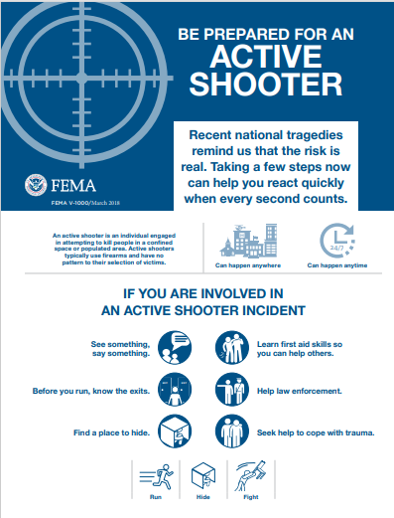
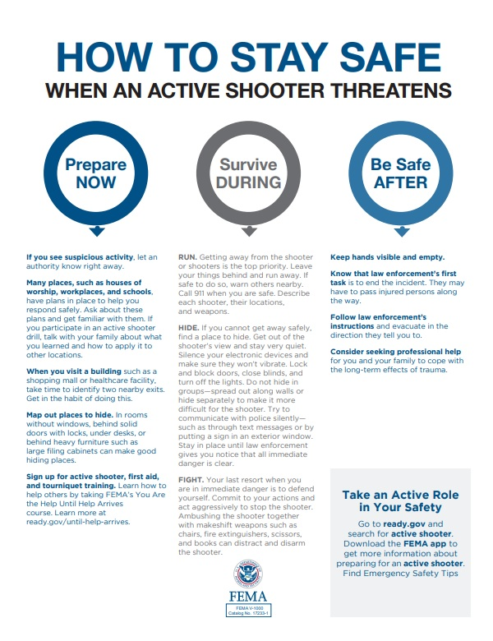
APPENDIX II – Office/Teaching Area Inspection List

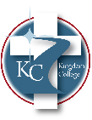OFFICE/TEACHING AREA INSPECTION CHECKLIST

Person Conducting Inspection: _________________________________
Location Inspected: __________________________________________
DATE: _____________________________________________________
GENERAL YES NO NOTES:
FLOORS: clean, dry, and free from debris, clutter, and trip hazards
Signs are posted when floors are wet (e.g. when floors are washed, spills)
Aisles are marked, clear, and unobstructed
Stairs and landings kept clear and unobstructed.
Stairwells adequately lit: steps, treads, etc in good condition
Furniture/Office equipment secure from tipping; appropriate for work being done
Exits, Entrances & Exterior Parking Lot | YES | NO | NOTES:
Doors are not blocked.
Routes, signs, and doors are clearly marked; exit signs are easy to see; outside entrances and parking lots are clearly lit.
Walkways and parking lots are free from trip hazards/debris.
Emergency exits have been identified and easily located in all areas
Environment | YES | NO | NOTES:
Lighting levels are adequate; work areas free from glare
Air quality adequate
Temperature and humidity adequate
Student chairs, desks, etc, are free from hazards and are comfortable enough to ensure productive, distraction-free learning
The Occupational Health and Safety Act posted
Temperature and humidity adequate
Fire Protection and Warning Systems | YES | NO | NOTES:
Emergency lighting; adequate lighting tested and record of annual inspection
Portable fire extinguishers: appropriate type, readily available and inspected
Fire exit doors: In good repair, unlocked and free from obstruction (both sides)
Fire/emergency alarm systems if applicable, are operational; fire exit signs lit
A fire and evacuation plan has been posted.
Hygiene and First Aid | YES | NO | NOTES:
Washrooms are clean (chemicals are stored)
Washing facility available (soap, warm water)
Washrooms are clean (chemicals are stored)
First Aid kits available in office areas
Material Handling and Storage | YES | NO | NOTES:
Materials, including any flammable products, are safely stored.
Storage shelves are loaded only to capacity, and heavy, awkward items are lower.
Step/Ladders have non-slip surfaces and are in good condition. Secured when stored.
Electrical | YES | NO | NOTES:
Extension cords are secured and in good condition (no exposed wires or bent prongs)
Portable hand tools are grounded or double insulated; cords in good condition.
Clear access to electrical panels and no combustible material stored/posted with 24 inches around
Security | YES | NO | NOTES:
Training on safety/workplace violence/ active shooter conducted with employees in person or electronically
Safety measures are in place for anyone working alone.
Other Safety Concerns Identified | YES | NO | NOTES:
APPENDIX III – Kingdom College Administrative Offices
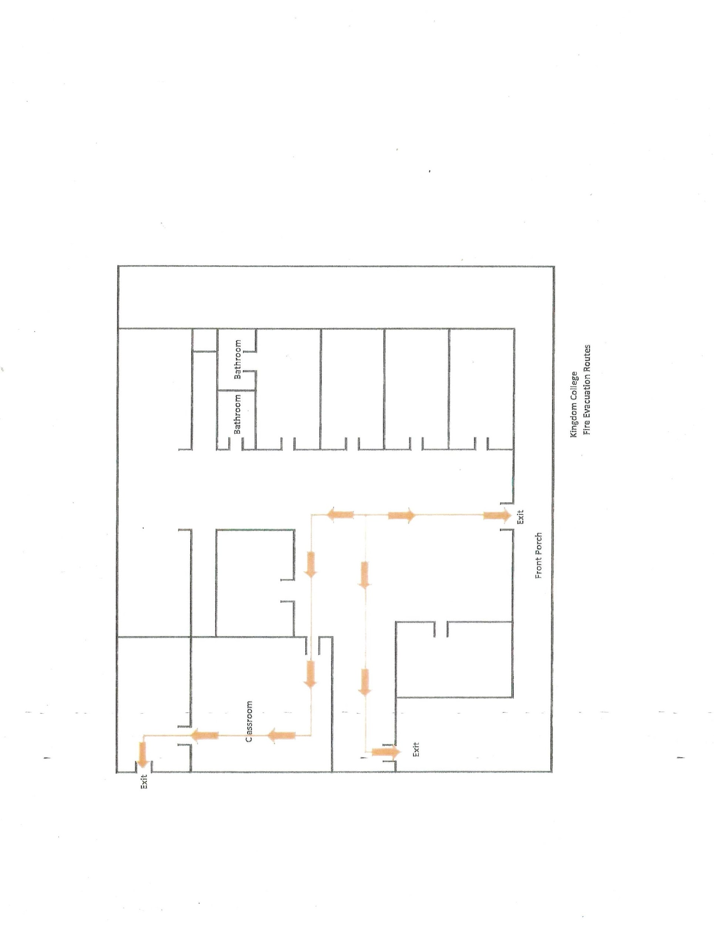

APPENDIX V – Pandemic Response Policy
APPENDIX IV – Kingdom College Education Center/Classrooms

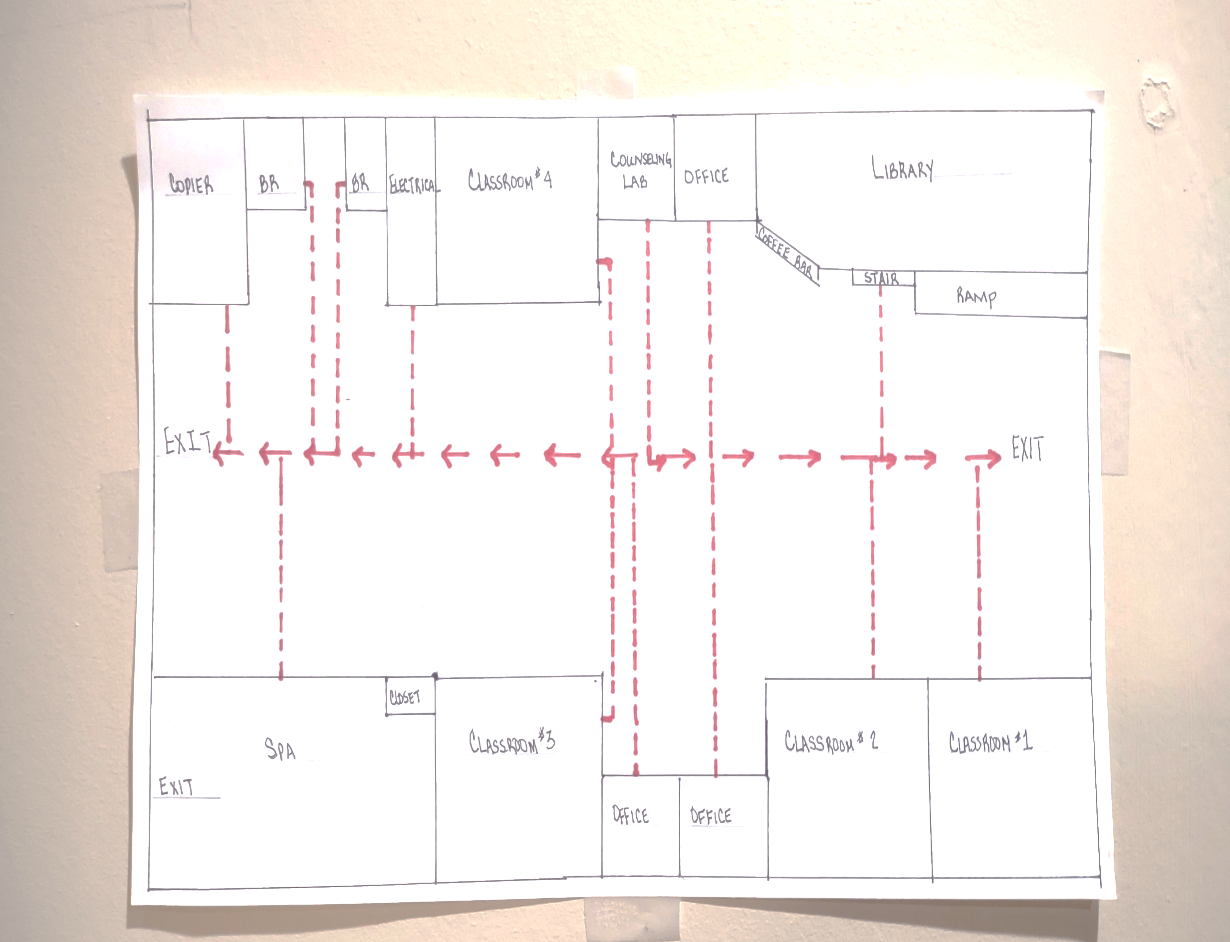
APPENDIX V – Pandemic Response Policy

KINGDOM COLLEGE COVID-19 PANDEMIC POLICY

Purpose: Due to the COVID-19 Pandemic, the following policies and procedures are outlined to ensure the safety and welfare of the staff, students, and faculty of Kingdom College. Due to the changing nature of the national, state, and local response to the COVID-19 threat, nothing in the policy will preclude the President’s ability to take immediate action if necessary for safety purposes or to ensure compliance with legal requirements.

Face Coverings: Face coverings are strongly recommended in all Kingdom College settings where a minimum 6-foot distance cannot be kept between individuals of different households.

Cleaning/Sanitation: All employees will follow proper housekeeping and sanitation procedures. This includes but is not limited to daily wiping of commonly touched areas such as door handles, light switches, phones, or other common areas. Employees will limit contact with other employees’ workstations to include computers, phones, etc., as much as possible.

Confirmed Positive: In the event that a staff member tests positive for COVID-19, that staff member will not be allowed to enter back into the office/work area for a period of 14 days from the onset of symptoms or the positive test (whichever comes first) and have a minimum of 48-hours without a fever without taking fever-reducing medication. The same will apply to students reentering the classroom environment. Any staff member who had direct contact with the infected staff member for more than 15 minutes at less than the 6-foot distance requirement will be tested prior to being able to return to work. During the 14 days subsequent to the direct contact, any employee showing symptoms will be sent home until a test can be confirmed as negative. The President retains the right to determine alternative schedules within the office environment during the 14-day period following a confirmed positive for the purpose of limiting in-person contact between the staff members.

Chris Bryant
Kingdom College
Director of Human Resources/Risk Management
Office: (334)785-5042 (x304)
Email: cbryant@kingdomcollege.net
Cell: (334)389-1379

