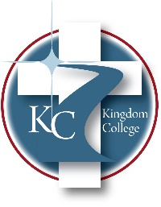
KC 300.28
Policy on Use of Facilities
Last Revision/Approval Date: 03/02/2023
______________________________________________

Kingdom College’s comprehensive risk management program includes the protection, upkeep, and ongoing maintenance of the physical resources under the ownership or use of the College. This risk management plan ensures adequate safety inspections occur, sites are free from hazards for students, faculty, and guests, and the proper insurance coverage is in place. Site visits are done periodically by the College’s loss control representatives from the various insurance plans. These coverages include but are not limited to general liability, professional liability, worker’s compensation, property, and cyber liability protections. The proper levels of property insurance are maintained in order to allow for the continuation of services with limited impact on students and faculty in the event of catastrophe or loss of use.

