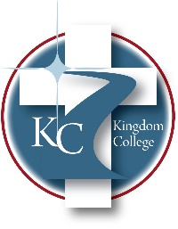
KC 300.4
Training and Development
Last Revision/Approval Date: 12/16/21
______________________________________________
The President and the Director of Human Resources shall be responsible for developing employees' skills through in-service training, investigating training programs outside Kingdom College and referring employees to those programs, and making recommendations on whether Kingdom College should pay for such training.

