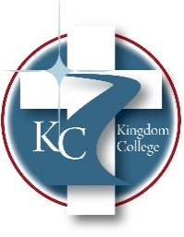
KC 400.14
Travel Reimbursement Policy
Last Revision/Approval Date: 03/02/2023
__________________________________
Kingdom College's policy reimburses employees and volunteer board members for pre-approved travel-related expenses, including transportation, hotels, and food. These expenses must be reasonable, necessary, job-related, and pre-approved by the President.
Kingdom College will only reimburse for pre-approved travel-related expenses when the employee provides documentation of the expense with receipts from purchases or other verifiable documentation.
Employees seeking reimbursement must complete the Travel Reimbursement Request form from the HR Director. The form must be fully and accurately completed and submitted to the President. All receipts should be scanned/attached and submitted with the form.
Kingdom College will reimburse employees for using their personal automobiles in accordance with the federally approved mileage rate for business use of personal vehicles.
Reimbursement of meals when there is no overnight travel should be paid by the organization only when the meal has a defined business purpose.
For out-of-area travel, Kingdom College will reimburse all pre-approved travel-related actual costs, such as hotel accommodations, transportation to and from the destination, including airline, train, or bus tickets, taxicab fares, meals, and gratuities, etc. Employees and volunteers should travel at the lowest available airfare to accommodate the purpose of the business trip.

