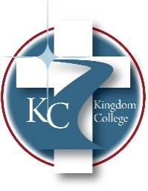
KC 400.8

Investment Policy
Last Revision/Approval Date: 11/17/2025
__________________________________

Kingdom College maintains an investment account with Edward Jones, Headland. This account is open for donations of various types of stocks/funds, etc. The CFO and Kingdom College President will have direct access and accountability for this account. Still, the Board must approve the sale of investments for use of operating expenses or major purchases. Kingdom College will do its best to make informed decisions on the type of stocks/funds, etc., that it purchases to make sure they are not out of line with what God would have us be a part of. Kingdom College retains the right to sell any donation of stocks/funds received that are not aligned with a Godly character.

