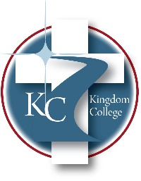
KC 500.6
Community Involvement
Last Revision/Approval Date: 3/7/2024

It is essential to the growth of Kingdom College to be an active, participating member of the local community. This process is achieved by participating in local community events, i.e., Headland Fall Festival and Christmas of Lights. Further, it is important that Kingdom College develop events in which community members can engage with members of the faculty, staff, and students of Kingdom College, i.e., local presentations to schools, community awareness sessions for Bible study of community mental health information, speaking at local churches about Christian education. The process of developing activities generally revolves around the community's perceived needs at the time; this information is gathered from business and industry through membership in the local chambers of commerce, local church connections, or local school connections. Staff and faculty assemble programs and present them to the community as needed. Kingdom College staff, faculty, and students are asked to participate in local community events that others put together. These types of activities keep Kingdom College fresh and growing to make the community a healthy, thriving setting for everyone.

