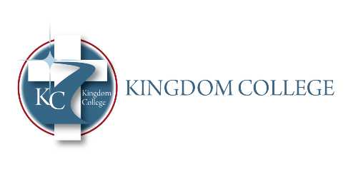
STRATEGIC PLAN
2025-2028 ASSESSMENT PLAN

ASSESSMENT CYCLE

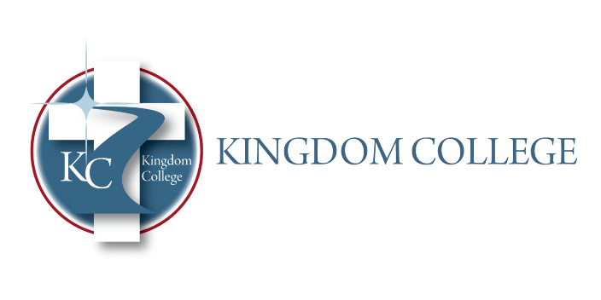

Preparing, equipping, empowering

OUR MISSION

Kingdom College is a Christian college dedicated to preparing and equipping God’s people for works of service (Ephesians 4:11-12 NIV) by teaching students on the undergraduate and graduate levels to perform works of service in the areas of Biblical Studies, Psychology, and Christian Clinical Mental Health Counseling.

OUR VISION

A Christian college sending forth His people empowered by The Holy Spirit through love to fulfill His divine plan as seen in Acts 1:8, “But you will receive power when The Holy Spirit comes on you; and you will be my witnesses in Jerusalem, and all Judea and Samaria, and to the ends of the earth,” and Matthew 28:19, “Therefore go and make disciples of all nations, baptizing them in the Name of The Father, and of The Son and of The Holy Spirit” in the fields of Biblical Studies, Psychology and Clinical Mental Health in order to establish strength, hope and soundness to the people in the global and local market place.

- Strategic Initiatives
  - Kingdom College will establish and maintain a school culture that encourages the equipping of His people on the undergraduate and graduate levels for works of service based on Ephesians 4:12-13.
  - Faculty will dedicate themselves to the students’ future through rigorous coursework and challenging academic goals following their program’s assessment plan.
  - Kingdom College will maintain a Christian worldview in all its activities.

- Strategic Plan Goals/Objectives
  - School Culture
    - Kingdom College desires to develop and maintain an environment that fosters and nourishes learning and inspires students, faculty, administration, and staff.
    - The culture of the school will determine and support the mission and vision of the school.
    - Kingdom College will establish and maintain a school culture that encourages the equipping of His people on the undergraduate and graduate levels for works of service based on Ephesians 4:12-13
    - The future of the Kingdom will continue building on the mission and sending forth His students empowered by the Holy Spirit through love to fulfill His divine plan based on Acts 1:8 and Matthew 28:19.

  - Faculty
    - Faculty will utilize their gifts and talents to equip and empower students to go forth and perform the acts of service to which they are called to interact with students in both the academic and spiritual arenas, building faculty-student solid relationships.
    - Faculty will dedicate themselves to the students’ future through rigorous coursework and challenging academic goals. They will model scholarly standards and assist students in developing their standards of academic excellence.
    - Faculty members who are experienced, mature workers in their various fields and come from strong academic backgrounds will be hired.

  - Policies and Procedures
    - Personal assistance and one-on-one relationships will reflect Kingdom College’s desire to imbue every component of our services with Christ-likeness to support and strengthen the mission and vision.
    - Kingdom College Policies and Procedures Manual provides structure for the college revolving around the call to empower and equip students to go forward through the power and wisdom of the Holy Spirit, and will offer potential students a path to their future, designed to welcome them into their academic journey toward their calling and dream.

  - Human Resources
    - The Human Resources Department of Kingdom College will revolve around God’s work that admonishes us to respect, love, and care for His children, which will be demonstrated in the work environment.
    - Kingdom College will allow God to help guide the hiring decisions by praying and seeking Him to fill the positions with His choices as positions become necessary.
    - Each candidate for employment is vetted for their academic background and their value as to what they bring to our students and college.

  - Financial
    - Kingdom College will pursue funding and recruiting students through appropriate marketing, donations, and grants.
    - Tuition and fees will be a source of funding.
    - Kingdom College’s Chief Financial Officer will maintain and manage accurate records and reports in accordance to state and federal policies and Kingdom College board policies.
    - Kingdom College will obtain timely and accurate annual audits.

  - Technology
    - Kingdom College will offer hybrid and online classes.
    - Kingdom College will maintain a contractual agreement with an IT company.
    - Kingdom College will offer online library resources (i.e., Logos, Alabama Virtual Library).
    - All student and employee data will be protected
    - Classrooms and labs will be equipped with technology to enhance teaching and learning.

  - Library Resources
    - The library will have an adequate collection appropriate for the courses and programs offered.
    - Students and faculty can search for titles and topics through the library software program Librarycat.org.
    - Textbooks and additions will be added to the collection from instructor feedback.
    - All students and faculty will have access to the Alabama Virtual Library and will have access to Logos Faithlife Remote Research Library as determined by degree.
    - Students and faculty will have access to a Biblical Counseling Database.

  - Curriculum
    - Through prayer and careful planning, educators who are current in their respective fields of study will continue to develop rigorous curricula for the various programs and integrate the Christian worldview.
    - Students will receive advisement in programs, courses, and careers
    - Students will achieve Student Learning Outcomes (SLOs)
    - Kingdom College students will leave well-prepared and well-grounded in their programs’ content and well-versed in God’s Word and how His Word will go with them into their fields, whether ministry or marketplace ministry across the globe.

  - Program Goals and Implementations
    - Kingdom College will remain on track for improvement for our students and the community they serve upon graduation.
    - Institutional, Strategic Plan, and Program Assessments will be maintained

Strategic Plan  Goal | Objective | Assessment: Evidence/Measure | Responsibility of: | Outcome
School Culture |  |  | Director of Human Resources, Director of Enrollment and Student Services
 | Kingdom College desires to develop and maintain an environment that fosters and nourishes learning and inspires students, faculty, administration, and staff. | Signing of Statement of Faith by students, faculty, and Board.
 | The culture of the school will determine and support its mission and vision. | The signing of the Memorandum of Understanding by all students for each course
 | Kingdom College will establish and maintain a school culture that encourages the equipping of His people on the undergraduate and graduate levels for works of service based on Ephesians 4:12-13. | Faculty, staff, and student evaluations
 | The future of the Kingdom will continue building on the mission and sending forth His students empowered by the Holy Spirit through love to fulfill His divine plan based on Acts 1:8 and Matthew 28:19. | Faculty, staff, and student evaluations
Faculty |  |  | Chief Academic Officer
 | Faculty will utilize their gifts and talents to equip and empower students to go forth and perform the acts of service to which they are called to interact with students in both the academic and spiritual arenas, building strong faculty-student relationships. | Student evaluations
 | Faculty will dedicate themselves to the students’ future through rigorous coursework and challenging academic goals. They will model scholarly standards and assist students in developing their standards of academic excellence. | Review of course syllabi and Canvas courses  Faculty self-evaluations
 | Faculty members who are experienced, mature workers in their various fields and who come from strong academic backgrounds will be hired. | Faculty evaluations
 | Each candidate for employment will be vetted for their academic background and the value they can bring to our students and the college.
Policies and Procedures |  |  | All Staff and Administration
 | Personal assistance and one-on-one relationships will reflect Kingdom College’s desire to imbue every component of our services with Christ-likeness to support and strengthen the mission and vision. | Review of admission policies and procedures periodically
 | Kingdom College policies and procedures provide structure for the college revolving around the call to empower and equip students to go forward through the power and wisdom of the Holy Spirit and will offer potential students a path to their future designed to welcome them into their academic journey toward their calling and dream. | Review of all policies and procedures periodically
Human Resources |  |  | Director of Human Resources/Risk Management
 | The Human Resources Department of Kingdom College will revolve around God’s work, which admonishes us to respect, love, and care for His children, which will be demonstrated in the work environment. | Background checks
 | Kingdom College will allow God to help guide the hiring decisions by praying and seeking Him to fill the positions with His choices as positions become necessary. | Review of faculty and staff vitae, transcripts, and references.  Staff evaluations  Student evaluations
Financial |  |  | Chief Financial Officer
 | Kingdom College will pursue funding and recruiting students through appropriate marketing, donations, and grants. | Student financial reports
 | Tuition and fees will be a source of funding. | The Chief Financial Officer’s report at each board meeting
 | Kingdom College’s Chief Financial Officer will maintain and manage accurate records and reports following state and federal policies and Kingdom College board policies. | The Chief Financial Officer’s report at each board meeting
 | Kingdom College will obtain timely and accurate annual audits. | Annual independent audits
Technology |  |  | All Staff & Faculty
 | Kingdom College will offer hybrid and online classes. | Maintain the shared drive, which is backed up daily
 | Kingdom College will maintain a contractual agreement with an IT company. | Contractual agreement with IT reviewed and maintained annually
 | Kingdom College will offer online library resources (i.e., Logos, Alabama Virtual Library). | Professional development technology is provided annually
 | All student and employee data will be protected. | Employee and student data are protected daily via shared drives, secured file cabinets, or student information systems
 | Classrooms and labs will be equipped with technology to enhance teaching and learning. | Smart boards are utilized in all classrooms
Library Resources |  |  | Librarian
 | The library will have an adequate collection appropriate for the courses and programs offered. | Student evaluations and instructor surveys will determine the adequacy and appropriateness of the library and services.
 | Students and faculty can search for titles and topics through the library software program Librarything.com. | Library survey
 | Textbooks and additions will be added to the collection based on the instructors’ feedback. | Library survey
 | All students and faculty will have access to the Alabama Virtual Library. They will have access to Logos Faithlife Remote Research Library and the Biblical Counseling database as determined by degree. | Library survey
Curriculum |  |  | Chief Academic Officer & Department Chairs
 | Through prayer and careful planning, educators who are current in their respective fields of study will continue to develop rigorous curricula for the various programs and integrate the Christian worldview. | Curriculum review
 | Students will receive advisement in programs, courses, and careers. | Program maps will be maintained for academic advisement and reviewed for curriculum rigor.  Resources and support will be provided for students with disabilities and monitored by the Director of Enrollment and Student Services.  Students will be given career interest inventories to enhance future career choices.
 | Students will achieve Student Learning Outcomes (SLOs). | Assessment Plan implementation
 | Kingdom College students will leave well-prepared and well-grounded in their programs’ content and well-versed in God’s Word and how His Word will go with them into their fields, whether ministry or marketplace ministry across the globe. | The Director of Enrollment and Student Services will conduct an annual follow-up of graduates’ employment for five years.
Program Goals and Implementation |  |  | Administrative Staff & Faculty
 | Kingdom College will remain on track for improvement for our students and the community they serve upon graduation. | Program Assessment Plans identify Student Learning Outcomes, measures, and assessments, and student data is collected, analyzed, and reviewed annually.
 | Institutional Program Assessments will be maintained. | The Institutional Assessment Plan identifies goals and assessments, and data is collected, analyzed, and reviewed annually.
 | Strategic Plan Assessment will be maintained. | Strategic Plan Assessment Plan identifies goals and assessments; data is collected, analyzed, and reviewed annually.

Annual Analysis and Plans for Future Improvement:
Kingdom College’s Strategic Plan is a college-wide effort to promote data-informed decision-making that leads to institutional improvement and enhanced student learning. Assessments, data collection, analysis, and improvement plans will be conducted annually.

